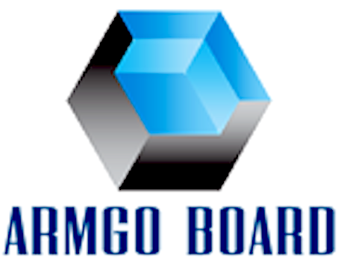
AUSSI ROSSROCK IMPORT PTY LTD
trade as arscaffolding system
ABN: 54148876037；can: 148876037
ADDRESS: 36-40 LIPOSN STREET.PORT ADELAIDE SA AUSTRALIA.
TEL: 08-84471089; FAX: 08-84820992
EMAIL: ARSCAFFOLD@QQ.COM

Disclaimer

We are the mgo board importer and manufacture, trade as ARMGO board, for retails supplier only, not for installation or will be professional installation adviser.
Our board are tested to comply Australian standard, but this is not means for all Australian installation standard. Customer must get professional advice for the purpose of use and correct way to install, which must suitable to use this material for your project, or comply BCA code to use this material for your project. There are lots of elements associated for installation with this material, such as engineer installation design, special screws, glue, flashing patch material or any special designed flushing material for this particular material.

All our material use guide documents and information from our installation manual or website are sourced from public information, that only provide general guidance. And in no way replaces the services of the professional consultants and relevant engineers designing. Our information and documents supplied on good faith and to the best of our knowledge was accurate at the time of preparation. User are advised to make their own determination as to the suitability of use this material in relation to their particular purpose or specific circumstances. Since the information contained in our advertising online or website may be applied under conditions beyond our control, no responsibility or liability can therefore be accepted by Aussi Rossrock or its staff for any loss or damage caused by any person action or refraining from action as a result of misuse of this information. And other parties for the use this material and design guide for any installation faulty or error, or what’s so ever the loss caused by use this material, unless this material are factory defect faulty. ARMGO panel or sheet products and systems undergo constant research and reflect ongoing performance enhancement. ARMGO panel and sheet are also constantly reviewed so as to reflect any changes in legislative building requirements and or general developments in common building practice, due to our commitment to continually development and improve our building system and material.

Attached some public published installations for your reference.

Managing Director

Guang Xing Yuan ( Peter)

30 Nov. 2015

